**Faculty Profile**

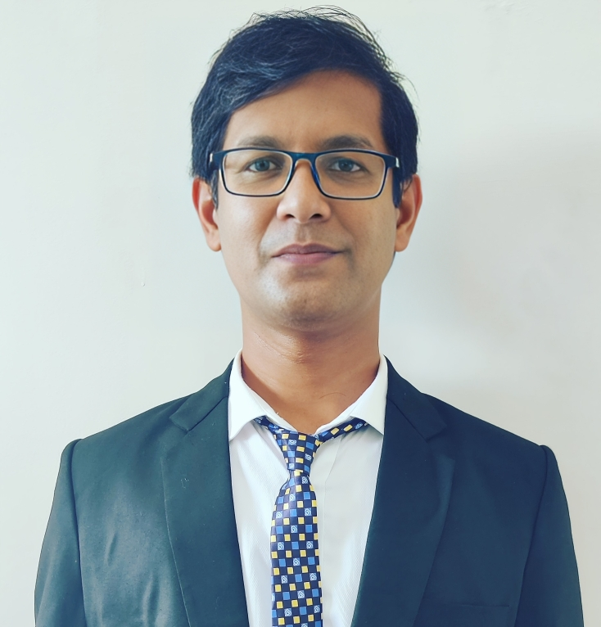

1. **Basic Information**

* **Name:** Dr. Yogesh Kumar Rathore
* **Designation:**  Assistant Professor
* **Department:** Computer Science and Engineering
* **Institution Name:** Shri Shankaracharya Institute of Professional Management & Technology, Raipur
* **Email ID:** y.rathore@ssipmt.com
* **Contact Number:** 9691990198

1. **Educational Qualifications**

|  |  |  |  |
| --- | --- | --- | --- |
| **Degree** | **Specialization** | **Institution** | **Year of Completion** |
| Post Doc (Pursuing) | Machine Learning | Singapore Institute of Technology | - |
| Ph.D. | Information Technology | NIT, Raipur | 2024 |
| PG | M. Tech. (Hons.) Computer Science and Engineering | Raipur Institute of Technology, Raipur | 2010 |
| UG | B.E. –Computer Science and Engineering | Raipur Institute of Technology, Raipur | 2005 |

1. **Teaching & Research Experience**

* **Total Teaching Experience**: 19 years, 1 month
* **Industry Experience**: *NA*
* **Research Experience**: 15 Years

1. **Courses Taught**

**List of key UG**

1. Computer Graphics
2. Operating Systems
3. Internet of Things
4. MATLAB Programming
5. Digital Electronics
6. Operations Research

**PG courses taught**

1. Soft Computing
2. Advanced Machine Learning
3. **Research Interests / Specialization**

* Machine Learning
* Deep Learning
* Optimization
* Applications of AI in Agriculture
* Image/ Video Processing
* Computer Vision
* Applications of AI in Healthcare

1. **Publications (Last 5 Years)**

* Journals - 30
* Conference Proceedings - 18
* Book Chapters / Books Authored – 14

1. **Research Guidance**

|  |  |  |
| --- | --- | --- |
| **Level** | **Awarded** | **Ongoing** |
| Ph.D. | - | 01 |
| PG | 16 | - |

1. **Awards & Recognitions**

NA

1. **Administrative Roles**

|  |  |
| --- | --- |
| **S. No.** | **Co-curricular & Field-based activities, contribution to corporate life & Management of Institution, Professional Development activities** |
|  | Dean (Training and Placements) |
|  | Member of the Board of Studies (CSE) at CSVTU |
|  | Co-ordinator of Vidhya Poshak Consultancy Project |
|  | Co-ordinator of NITTTR, Chandigarh-Remote Center (for FDP) |

1. **Professional Memberships**

* Professional Member of **IEEE Society**, Member ID: #98390321, Madhya Pradesh Section.
* Membership of the **IEEE Young Professional Society**.
* Professional membership of **IFERP** (Institute for Educational Research and Publication )
* Life Time Membership of the Society for Technologically Advanced Materials (**STAM**), India. (Membership no. LM-ET-0848).

**Web Presence**

* Google Scholar: - <https://scholar.google.com/citations?user=kMvagg4AAAAJ&hl=en>
* ORCID: - <https://orcid.org/0000-0003-0314-5611>
* ResearchGate: - <https://www.researchgate.net/profile/Yogesh-Rathore-2/research>